Annex 1: Implementation Progress with RFU and National/Regional Levels

- Update on the RFU - Project Monitoring and Evaluation with the AAU: In addition to the achievements provided in the earlier sections of this report, the RFU also realized substantial progress in various aspects as per their mandate given in the project implementation. Among the outputs are:

- RFU Online Monitoring and Evaluation Digital Systems & Database Platform:

The development of the ACE impact project digital reporting system was structured into 3 phases; the report submission phase, the report verification and generation phases, and finally the cumulative payment processes phase. The key highlights of the digital reporting system from May 2021 to October 2021 include: (i) adding all the approved DLR 4.3 milestones on the digital reporting system; (ii) completing work on baselines and targets; and (iii) fixing bugs in the contact database feature.

The RFU has completed all iterations of the report generation phase. The digital reporting system can now produce progress reports of the centers on aspects including results framework, cumulative reports on enrolment and publication, and many others. In addition to this, with this system, the Word Bank team can now check overall progress of the centers as well as to carry out verification process of the DLI6 components directly in the system.

With the growing demands of the project, some modifications were made relating to updating the submission fields for DLR 4.1 (Programme Accreditation), expanding the thematic areas on the system, and updating the submission fields for DLI 6.

The remaining phase left to complete is the Payment Process. This phase will include the following features; submission of Eligible Expenditure Programs, generation of verification letters, and calculating the cumulative payment records. There will also be some work to be done on the submission fields for the DLI 7 components.

- Capacity Building Initiatives for ACE Impact host institutions:

The RFU continued to offer tailor made capacity building webinars and information sessions for the ACE Impact institutions to support the implementation of DLI 4.2 and 7.3 on International Program and Institution accreditation, respectively. To this end, separate webinars were organized from 3rd June to 8th July 2021 delivered by six different accrediting agencies including: the Agency for Public Health Education (APHEA), Belgium, Royal Society of Biology (RSB) UK, Accreditation Agency for Engineering, Informatics, Natural Sciences & Maths programmes (ASIIN), Agency for Quality Assurance (AQAS), CTI – Commission des Titres d’Ingenieur, and HCREES. By the end of these sessions, institutions were aware of the requirements for successful institutional accreditation. Some of the centers have already embarked on the processes of institutional accreditation. Similarly, a DLI 5.3 webinar on entrepreneurship and innovations was executed on 1st October 2021. The webinar drew reputable key speakers across the continent who shared experiences and best practices on university entrepreneurship and innovations.

In addition to the sessions outlined above, the AAU in collaboration with the Bank also organized a webinar on digital transformation strategies. This initiative focuses on five key areas to help institutions drive the necessary digital transformation changes systematically: Institutional Management and Administration, Education (Teaching and Learning), Research, Outreach and Networking, and Digital Infrastructure.

The first introductory session was held with an aim of providing a roadmap to the digital transformation. At the end of this session, a survey was shared out with all the participants from the ACE host institutions to provide information on their status in areas of digital education, research and management. It is based on the survey results that 12 ACE host institutions were selected to continue with the journey on digital transformation. A special one weeklong workshop was carried out October 11- 15, 2021 engaging the 12 selected institutions. The workshop covered the following topics: Driving Change Toward Digital Transformation: Education and Training Delivery at KOREATECH; Mapping Higher Education Institutions onto the Sustainable Development Goals (SDGs): A case study of the University of Auckland; Case Study: Improving Student Engagement with Digital Education at ENSPY; and Commercialization of Research and Patents

- Implementation Support Missions to the ACEs:

Since the last Regional Workshop in May 2021, the World Bank and AAU planned on slowly opening for in-person supervision missions to Centers that needed urgent support to enable them catch up with implementation of activities. Unfortunately, in August 2021 when plans were underway for such missions, the COVID-19 Delta variant surged leading to suspension of physical missions for the project. As a result, virtual implementation support missions continued and were organized engaging subject matter experts with their assigned ACEs from June 2021 to date. Specifically, the missions aimed at preparing the ACEs for Mid Term Review (DLI achievements, earning and fund utilization) and reviewing the performance their approved in the 2021 Annual workplans.

The RFU successfully coordinated 22 missions across 6 of the projects participating countries (Benin, Burkina Faso, The Gambia, Ghana, Niger, Nigeria, Senegal). These exclude special meetings held with Niger centers, Togo centers, and the Ministry of Higher Education in Togo.

COVID continues to be the cause of delays in implementation of activities. Centers with unsatisfactory performance are being supported through special/ monthly meetings to speed up their implementation activities to meet the Mid-Term Review objectives.

- RFU Procurement of Services and goods:

In line with its core responsibility of implementing most of the activities under Component 3 of the ACE Impact Project (regional facilitation and implementation support to the centers), the RFU has (a) procured goods to support activities at the Secretariat and (b) contracted firms and individuals to provide consultancy services to the Centers.

The following service contracts have been signed and are being implemented:
- Bibliometric verification and DLI validation
- 21 Subject Matter Specialists to support the Centers
- Development of Monitoring, Evaluation and Learning Platform
- Procurement Officer – Francophone
- Environmental and Safeguards Officer – Francophone
- Capacity Building in digital education

The following consultancies are under implementation i.e. procurement processes are underway: (i) Independent External Evaluation of Development Impact of the ACEs (DLI 2); and (ii) Consultant to undertake Graduate Tracer Studies.

- National and Regional Level - Project Monitoring and Evaluation: The project’s national and regional facilitating units continued to provide oversight support to the ACEs as per the respective signed financing agreements. The outline below summarizes the progress made by the National Facilitating units namely, the National Universities Commission in Nigeria, the Ghana Tertiary Education Commission in Ghana, the Ministry of Higher Education, Scientific Research and Innovation in Burkina Faso, The National Project Coordination Unit in the Gambia, and the Regional Facilitating Unit at the Association of African Universities (Ghana).

- National Universities Commission (NUC)

The NUC is still dedicating its efforts and resources towards launching the ACE Impact project in the country. Recently, the ACE Impact Project has received parliamentary approval captured under the country’s national borrowing plan. Also, the financing agreement for the ACE Impact has been signed. Furthermore, the Performance and Funding Agreements between NUC and the Centers of Excellence have been signed. Likewise, all the Centers achieved basic and full Institutional Readiness for project implementation as reported during the last progress reports. Additionally, the ACE Impact Work and Procurement Plans for the Centers of Excellence and the NUC PIU for 2021 have been submitted and approved. To ensure a well-structured environment to manage the projects implementation, the NUC created a Directorate of Special Projects which houses the ACE Impact project implementation division and deployed staff to the areas of Project Management, Accounting & Finance, Monitoring and Evaluation, Communications, Audit and Procurement. In a bid to build capacity in the universities hosting the centers, the NUC organized a training on online content delivery in partnership with Worcester Polytechnic Institute (WPI), Massachusetts, USA. The training was facilitated by the Nigerian Research and Education Network (NgREN).

In addition, a robust accounting software was procured, and several successful trainings have been organized for the ACE Impact PIU and ACE Impact Centers Accountants, Finance Officers and Auditors. In addition, on the World Bank’s Client Connect platform, project accounts have been opened with approved signatories by the ACE Impact PIU and Centers. To ensure effective communication of the NUC and centers activities, events, announcements and more, the ACE Impact website was updated with relevant content. The NUC ACE Impact PIU identified international programme and institutional accreditation agencies/bodies for higher education and shared the details with the centers. The centers are making progress towards international accreditation with their selected accreditation agencies.

The NUC is currently going through a procurement process of acquiring High Performance Computing servers, Network Devices, Outdoor Wi-Fi Equipment, Learning Management System (LMS) and Electronic Data Management System (EDMS) for the ACE Impact and the Sustainable Procurement, Environmental, Social Standards Enhancement (SPESSE) projects. The NUC has developed a Sexual Harassment Action Plan, as well as the Terms of Reference for the engagement of a Gender Based Violence (GBV) Consultant. The GBV consultant will support the ACE Impact PIU in the development of SE/SH (Sexual Exploitation/Sexual Harassment) action plan. Officers of the ACE Impact PIU and Centers participated in the Virtual Mission to ACE Impact Centers on DLI 4.3 - Improved teaching and research environment as well as DLI 7.

- Ghana Tertiary Education Commission (GTEC) – Ghana (formerly National Commission for Tertiary Education (NCTE))

The GTEC in the last six months, based on its approved work plan, carried out numerous activities, some of which are still ongoing. One of the key activities carried out by the NFU was the successful organization of a training workshop in Environment and Social Safeguards, Monitoring and Evaluation, and Endowment and Independent Fund Raising in September. This training workshop was a follow up to an earlier workshop organized in April on Financial Management and Procurement. Participants included the main workforce of the centers (Center leaders and their deputies, project managers, financial specialists, procurement specialists, M&E specialists, and safeguards specialists. Participants were awarded certificate for their participation. The AAU were invited to participate and also give presentations on some of the key tasks expected of the centers in the implementation of their activities.

The NFU is also engaged in several procurement activities as part of operationalizing its Annual Work Plan. For instance, tenders have been opened and evaluation of tenders conducted for the procurement of a 4x4 SUV to be used for project activities. Also, an evaluation of tenders to select a consultant to execute the setting up of a video conferencing facility and the development of a project website dedicated for ACE impact. These activities are expected to be completed before the end of the year 2021.

The GTEC is scheduled to hold a Country Review meeting on the 29th of October 2021 with all the 9 centers and their teams. The meeting will be used to discuss among others the progress status of each center, the challenge facing centers and propose suggestions to remedy some of the challenges.

- The Ministry of Higher Education, Scientific Research and Innovation (MESRSI) - Burkina Faso

The Ministry of Higher Education, Scientific Research and Innovation (MESRSI) as the national facilitator of ACE Impact in Burkina Faso continued to provide technical support to their four ACE Impact centers. Among the achievements include Review Committee (RC) of the budgetary programme "Higher Education" chaired by the Secretary General of the MESRSI. The agenda of the meeting included a review of the technical and financial implementation of ACE Impact activities, discussions on challenges encountered by ACE teams, and plan for the next steps. In addition to this, on 15 September 2021, the National Coordination Unit held a meeting with the Minister of Higher Education, Scientific Research and Innovation to provide the status update on activities of the ACEs in view of the mid-term review. It was agreed that a broader meeting be held all the actors of the centers of excellence (the heads of the AEC host institutions, the financial chain, the ACE teams and the national coordination) in order to find solutions to the problems that hinder the fund utilization of the project.

It is also worth noting that the Ministry has acquired licenses for the financial management software management software TOM2PRO which have been made available to all five ACEs in Burkina Faso. As part of the finance best practices, The National Coordinating Office engaged external auditor to carry out financial audits of the five ACEs for the year 2020 and the two universities for the year 2018 (the universities for the year 2018 (Nazi BONI University which houses the CEA ITECHMTV and Joseph KI-ZERBO University which houses the CEA CFOREM and CEFORGRIS).

Within the framework of the PASET/RSIF initiative, the coordination participated in a videoconference meeting on 13 August 2021 following a call issued by ICIPE to recruit four additional universities to host students under the RSIF programme. During this meeting the Center of Excellence for Training and Research in Water and Sanitation Water and Environmental Sciences and Technologies in West and Central Africa Center (2iE) was selected.

Finally, the National Coordination has put in motion a visibility mechanism of the ACE Impact project activities at the national level including (i) the production of an audiovisual advertorial on the activities of the five ACEs and those of the National Coordination; and (ii) the creation of a web page for the coordination and the centers of excellence via a link on the website of the Ministry of Higher Education.

- Project Coordination Unit, the Gambia

During this period, the Emerging Center under Gambia Technical Training Institute (GTTI), registered a number of milestones amongst which include the final phase of the process to transform GTTI into a University of Science Engineering and Technology (USET). This was after exhausting all the necessary procedures required by the National Accreditation and Quality Assurance Authority (NAQAA) mandated by the Government of The Gambia to accredit and license universities established in The Gambia. Contracts were signed with Kwame Nkrumah University of Science Engineering and Technology and De Monte Fort University of Leicester in UK.

As part of fulfilling the requirement of the World Bank, the establishment of the USET was followed by the appointment of a university administrator to oversee the mentorship programmes, educational programmes, and transformation process over the remaining stipulated period under the ACE Impact project. Two DLI’s (DLI 4.3 and DLI 7) were submitted during the year under review and are being evaluated by the AAU and WB. Under DLI 4.3, the Emerging Center submitted for the Civil works for the new USET campus to construct three faculties (civil, mechanical, and electrical/electronic) which also include laboratory equipment, smarting teaching and learning facilities. Under DLI 7 the center under the leadership of the university administrator, is developing the regional strategy for USET.

The first year of the BSc. programmes is at its final stage and the students have started their end of academic year exams to move into the second year. Lecturers from KNUST has been visiting the Center for the period of this academic year to deliver lectures as stipulated in the contract with GTTI. Intake for the second cohort of the BSc programme under the Emerging Center STEE will commence in January to coincide with the release of the WASCE results. The PhD students in Ghana also finished their courses and some are working on their research proposals whilst others are working on their research. Those at the research stage were given their research support with the recommendation of their supervisors. The Ministry of Higher Education, Research, Science and Technology has secured the university site for the construction of the new campus and the PCU has submitted the final draft of the ESMP and EIA for evaluation to the AAU and WB.

Over this period, key challenges have been (i) the coordination of the programmes for the entrepreneurship and quality assurance to be offered by DMU and the engineering programmes being offered by KNUST (It is hoped that before end of 2021, both parties will come to terms under the leadership of the administrator); and (ii) the cost of internet (MB Data for connectivity) for the online classes.

- RSIF Component Update
- Summary of Overall Progress under both First and Second ACE Impact

      - Five ACE Impact countries (Benin, Burkina Faso, Ghana, Nigeria and Senegal) are contributing to RSIF as shown in Table X below. Signing of subsidiary agreements (SA), status of work plan, and funds disbursement are at various stages.

Table X: Status of agreements, authorization and first disbursements as of October 2021
Country | SA signed | Work plan shared | First instalment disbursed | Comments
Burkina Faso | 30-Jun-20 | Yes | Yes | Second WP shared; disbursement request submitted
Ghana | 16-Dec-19 | Yes | Yes | Second WP shared; disbursement request submitted
Senegal | 23-Jun-20 | Yes | Yes | Second WP shared; disbursement request submitted
Benin | 8-Feb-21 | Yes | Yes | Second WP shared; disbursement request submitted
Nigeria | Signed by icipe on 11-Feb-21 | No | No | SA being revised by the Government of Nigeria

- Students are recruited to RSIF African Host Universities offering high quality PhD programmes in one of the five priority thematic areas agreed by PASET. The priority areas are: ICT including big data and artificial intelligence; minerals, mining and materials engineering; energy including renewables; food security and agribusiness; and climate change. RSIF students spend 6-24 months on research collaboration at an advanced international institution. The number of IPIs have increased to 19 during the current period.

- A total of 184 students¹ have been awarded RSIF PhD scholarships to date with a further 100 to be awarded in Cohort 4. Students are progressing well despite some Covid-related delays: Cohort 1 students are on sandwich placements; Cohort 2 students are at African Host Universities (AHUs) and matching is progressing well; Cohort 3 completed orientation training in July 2021 and are reporting to campus. RSIF student publications in high quality peer reviewed outlets have now surpassed 50. See RSIF scholars’ research publications digital repository here.
- RSIF selected a first round of research and innovation grantees in 2020. Four of the ongoing projects were competitively awarded to ACEs in Nigeria. Second round of grantees will be announced late 2021.These grants are financed from counterpart funding.
- A total of 120 PhD students are to be supported across four RSIF Cohorts from the ACE country contributions as indicated in Table 4. Recruitment of students is based on the timing of contributions and number of eligible candidates available. There were fewer eligible applicants from the Francophone countries, and about 17-20% of total applicants were female. Contracting with the Nigerian funded students in Cohort 3 is currently on hold subject to signing of the SA by the Nigerian Ministry of Finance.

Table 4. Student status for countries contributing through ACE projects
Country | End Date | Amount  (in US$ million) | Number of students to be supported² | Student distribution by cohort
 |  |  |  | Cohort 1 | Cohort 2 | Cohort 3 | Cohort 4
Burkina Faso | 31-Dec-23 | US$ 2 | 20 | n/a | 4 | 3 | 13
Ghana | 31-Dec-23 | US$ 2 | 20 | n/a | 10 | 9 | 1
Senegal | 31-Dec-23 | US$ 2 | 20 | n/a | 3 | 6 | 11
Benin | 30-Jun-24 | US$ 2 | 20 | n/a | n/a | 10 | 10
Nigeria | 30-Jun-24 | US$ 4 | 40 | n/a | n/a | 18 | 22

- Four additional RSIF African Host Universities (AHUs) have been competitively selected to offer PhD programs from cohort 4 onwards, bringing total to 15 AHUs, three per PASET thematic area. Among the recent addition to receive RSIF PhD students from 2022 are:
- The University of Abomey-Calavi, Benin, Center d’Excellence des Sciences Mathématiques, Informatique et Applications (SMIA) and
- Institute 2iE, Burkina Faso, Center d’Excellence pour la Formation et la Recherche en Sciences et Technologies de l’Eau et l’Environnement en Afrique de l’Ouest et du Center (CEA-IMPACT 2iE).

- RSIF 2021 Country Progress Reports have been prepared for each contributing country and provide further details on RSIF achievements to date and benefits to the governments³.
Benin | Burkina Faso | Ghana | Nigeria | Senegal
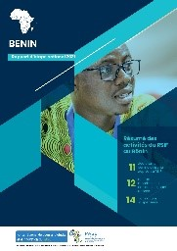 | 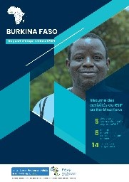 | 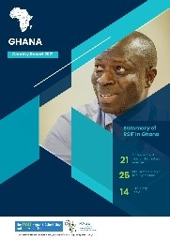 | 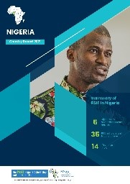 | 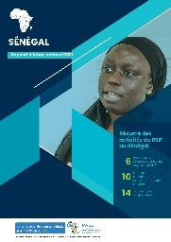
English | Français | English | Français | English | English | English | Français

- Key issues/ challenges with RSIF: The agreement between icipe and the Government of Nigeria has not yet been signed. Some students have already been awarded by the PASET Executive Board (EB) under this agreement and are now delayed. Discussions are on-going with the Government of Nigeria. Second disbursements for most of the agreements were delayed due to need for legal opinions from countries (with exception of Ghana) that appear to not have been prepared previously.

- Priority Next Steps with RSIF
    - Finalize agreement between icipe and the Government of Nigeria to enable students funding by Nigeria to begin their PhD studies.
    - Finalize second disbursements from the four countries for which agreements are active. Follow up on the legal opinions is underway.
    - Cohort 4 Call for applications closed on 7 October 2021 and expected to be selected by December 2021. Over 2100 applications were received for the Call.
    - Network strengthening, promoting regional and international collaboration on doctoral training, research, and innovation as well as support to RSIF AHUs accreditation.
    - RSIF pre-conference from 15-17 November 2021, online with panel discussion on the RSIF sandwich model and speakers from UGB, MITIC, Senegal amongst others. Hybrid RSIF conference hosted by Mohammed VI University in Morocco is planned for May 2022

- AAU/WB Inter ACE Thematic Networks

The Regional Facilitating Unit continued with activities leading to the operationalisation of the Inter ACE Networks. As of the 5th Regional workshop, a special presentation was made to officially announce the 8 selected networks after undergoing regions review process carried out by an Independent Evaluation Committee (IEC) constituted by the AAU. A two-step process for the evaluation followed namely, two days desk evaluation of the proposals by the Independent Evaluators and a half a day virtual technical meeting to discuss the evaluation engaging the independent evaluators. The successful networks have all addressed the feedback provided by the IEC and resubmitted to AA. Each of the network received grant award letters with clear terms and conditions of the network financing.

To jumpstart the implementation of networks activities, each team carried out so far a number of activities including (i) inception meetings to clarify roles and responsibilities of each partner; (ii) specific sub committees to support various functions including mobilising of additional resources for the network; and (iii) a staff and student’s symposium to share research work being done and to hold monthly planning meetings to review progress made so far. Table below provides information about the successful networks under the Inter ACE collaboration.

S/N | Name of the Network | Acronym of the proposed Network | Name of the Lead Center | Partner Centers
1 | West Africa Sustainable Engineering Network for Development | WASEND | KNUST Engineering Education Project (KEEP) | CoE EIE Benin STEE the Gambia  2iE  KEEP
2 | TRANSPORT AND LOGISTICS in SUSTAINABLE CITIES NETWORK | TL-SCN | AFRICAN CENTER OF EXCELLENCE IN LOGISTICS AND TRANPORT | CELT Djibouti CERVIDA TRECK
3 | Marine Litter Network | MALNET | Africa Center of Excellence in Coastal Resilience | C2EA - Benin AGIR ACECoR  VALOPRO
4 | West African Centers of Excellence for Energy Network | WACEENET | Africa Center of Excellence for Sustainable Power and Energy Development | RCEES - Ghana CERME - Togo ACEFUELS CEFOR ACESPEED
5 | WEST AFRICAN FOOD SAFETY NETWORK | WAFOSAN | AFRICA CENTER OF EXCELLENCE FOR FOOD SAFETY | PCMT - Guinea ACEMFS - Nigeria WACCIBP
6 | FOOD FOR WEST AFRICA | FOOD4WA | CERSA | CERSA AGRISAN WACCI CDA CEFTER
7 | AFRICAN DIGITAL EDUCATION NETWORK | ADEN | AFRICA CENTER OF EXCELLENCE ON NEW PEDAGOGIES IN ENGINEERING EDUCATION (ACENPEE) | ACEITSE - Nigeria CEA MS4MSSA ACETEL ACEMPEE
8 | REPRODUCTIVE, MATERNAL AND CHILD HEALTH ACE NETWORK | ReMCHAN | CENTER OF EXCELLENCE IN REPRODUCTIVE HEALTH INNOVATION (CERHI) | ACE PUTOR - Nigeria CEA PCMT- Guinea CERHI - Nigeria ACEPHAP -Nigeria ACEDHARS SAMEF ACEPHEM - Malawi

- ACE PARTNER Project

The ACE Partner project continues to network centers of excellence around the 4 priority themes: West African Network for Infectious Diseases (WANIDA), NET-WATER, Digital Science and Technology (DSTN), and Responsible mining activities and sustainable development (AMR2D).

The 4 thematic networks develop and share training programs, co-construct scientific projects of excellence and design actions to strengthen collaborations between the academic and socio-economic sectors. Despite the Covid-19 pandemic and in partnership with AAU, AFD & World Bank, the network coordinators were able to organize inter-ACE visits in Guinea, Côte d’Ivoire, Ghana, Benin, Senegal, Benin and Niger. The networks we able to physically meet, in Niger in June 2021 to exchange on responsible mining activities (AMR2D). A meeting organized by DSTN on digital science and technology and sustainability is planned in Saint Louis, Senegal (ACE MITIC) on 6th - 10th of December. Centers from AMR2D and NET’WATER met in Marseille, France in September 2021 to participate to the IUCN World summit. In addition, WANIDA is planning its general symposium early 2022.

The project currently supports 42 inter-ACE scholarship holders, at masters and PhD levels working on multidisciplinary scientific programs prioritized by thematic networks (restoration of mining sites, climate risk management, Covid-19, Big Data and Cyber security, etc.), leading to inter-ACE staff and student mobility. An inter-ACE training program is designed around specific needs raised by the network’s members. Several short training sessions are being disseminated around scientific and technological information, the systematic review, researcher vs entrepreneur.

The project is currently supporting the creation of MOOCS, writing scientific articles, designing research projects for competitive calls for tenders, policy briefs, and knowledge transfer. ACE Partner supports bringing the academic and socio-economic sectors together by identifying key public, and national and international private players in connection with our network’s actions. These actors are approached in a logic of co-construction of joint research and development programs, the optimization and development of ACE’s training programs and the hosting of trainees/internships.

In partnership with KEDGE business school and local incubators, ACE Partner developed a 100% digital pre-incubation training program design to support the creation of start-ups based on ACE’s academic expertise. Eight start-ups are currently being supported. We aim through this digital approach to strengthen local incubation actors and encourage the creation of new ones. Finally, as part of the institutional collaboration between IRD and AAU currently being signed, collaboration between networks will be formalized to ensure bridges between the AAU’s and ACE Partner’s thematic networks.For more information, click www.ace-partner.org

- Digital Transformation

C-CODE Call Launched: The AAU launched a detailed call for proposals on June 3rd, 2021 to all centers with a deadline of June 25th 2021. In order to help applicants understand the call requirements, special Question and Answer sessions were organized by video conference on June 18, 2021. A total of 12 applications were received from 6 different countries: 8 from anglophone and 4 from francophone universities. These include Nigeria: (University of Nigeria, Nsukka; Bayero University Kano; Federal University of Technology, Owerri; Federal University of Technology, Minna; Ahmadu Bello University Zaria; National Open University of Nigeria) Ghana: (Kwame Nkrumah University of Science and Technology, Kumasi; University of Energy and Natural Resources, Sunyani) Guinee-Conakry: (Université Gamal Abdel Nasser), Bénin: (Université d'Abomey-Calavi), and Togo: Universite de Lomé.

CCODE Selection completed: All application files were uploaded on a MS SharePoint server for easy access by both EPFL and AAU. The evaluation process consisted of two sequential steps: A Compliance Check and a Desk Evaluation of the submitted proposals.

Applications were evaluated along a grid of 12 axes, representing three main themes:
- The current technical and pedagogical environment (starting point)
- The commitment and perceived capacity of the university to implement the project (feasibility)
- The integration of the project in the wider vision and plans of the university (sustainability)
All applications were evaluated by EPFL and AAU experts. The final selection was discussed and approved by the EPFL, AAU and the World Bank.

Universities selected to host a C-CoDE:
- Bayero University, Kano, Nigeria – BU KANO
- National Open University of Nigeria, Abuja - NOUN
- University of Nigeria, Nsukka – UN NSUKKA
- University of Energy and Natural Resources, Sunyani, Ghana - UENR
- Université d'Abomey-Calavi, Cotonou, Bénin – UAC
- Université Joseph Ki-Zerbo, Ouagadougou, Burkina Faso – KI-ZERBO
The results of the selection process were communicated to successful applicants on September 9th, 2021.

C-CODE Kick Off meeting conducted
To provide additional information to selected universities and launch the operational aspects of the project, a kick-off meeting with the four anglophone universities was organized on Sept. 21st and another one with the two francophone ones on Sept. 22nd. These meeting were organized online (via Zoom) and were attended each time by the project leaders, the academic coordinators and the technical coordinators of each university.

The meetings were very useful as they helped clarify several organizational and technical aspects of the project and create a common understanding among all parties involved. In particular, the following subjects were exposed and discussed:
- The role of the implementation team
- The format and timing of the training programmes (experts, faculty, technicians)
- The physical and technical infrastructure of the C-CoDE

CCODE Project Documentation:
All universities have received the required documentation for the physical and technical infrastructure to put in place, as well as the profiles of trainees for the various training programmes. All documentation provided is readily accessible on the dedicated SharePoint server maintained by EPFL. A detailed, week-by-week, updated operational schedule was presented to participating universities. The following timeline representation provides a summary of the operations anticipated between October 2021 and end of July 2022:

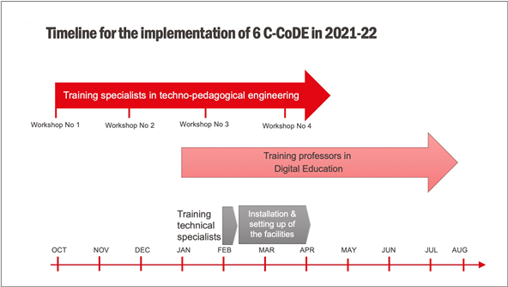

CCODE Project Implementation Initiated
- Training of Experts in digital Education
Each university has identified and confirmed 3 faculty members to be trained as experts in digital education.

University | Gender | Expert name
BU KANO | F | Binta ABBA
 | M | Mustapha Mohammed BELLO
 | M | Auwalu Sani SALIHU
NOUN | F | Juliet INEGBEDION
 | M | John OPARADURU
 | M | Musa RUNDE
UN NSUKKA | M | Nnenna E. IBEZIM
 | M | Emmanuel Chukwudi IHEKWOABA
 | F | Uche C. OGBUEFI
UENR | F | Mary ANTWI
 | M | Felix Amankwah DIAWUO
 | M | Komlavi AKPOTI
UAC | F | Pélagie HOUNGUE
 | M | A. Zéphyrin Magloire DOGNON
 | M | Gaston KPOTIN
KI-ZERBO | M | Jacob SANWIDI
 | M | Paul Marie MOYENGA
 | M | Natéwindé SAWADOGO
 | M | Bapindié OUATTARA (as a free auditor)

- The trainees were informed of the syllabus, and a preparation week was scheduled for the week of September 27th, so that trainees could get familiar with the training platform (Open edX) and study the preliminary material.

Training is delivered in 4 Workshops, as follows:
Workshop | Topics | Location
1 | Course design  Introduction to e-Learning  Needs analysis  Design of the lesson plan | Online
2 | Educational resources  Digital educational content  Assessments  Educational videos | Online
3 | Development & Implementation  LMS  Course set up | Online
4 | Delivery and Evaluation  Online teaching strategies  Course evaluation | Onsite (if possible)

ACE Impact IBM Partnership: The ACE Impact-IBM partnership is officially operational after the signing of the MOU to guide the operations. A call for student’s research Internships tenable at the IBM offices in Kenya and South Africa was circulated with a deadline of 8th October 2021. The selection process is currently on going and the internships are expected to be done virtually due to travel restrictions caused by the COVID -19 pandemic and visa processing time/acceptance for the students. In addition to this, the IBM is planning training session dedicated for ACEs which will be delivered in two tracks between October and November 2021. These are as below:

Track 1 - October 2021.
- IBM Bigdata Training
- Blockchian Developer
- Business Intelligence Analyst
- Security Intelligence Engineering
Track 2 for November 2021
- AI Analyst
- Cloud Application Developer
- IoT Cloud Developer
- Predective Analytics Modeler

Annex 2: Country Status Reports – As of August 2021

FIRST ACE IMPACT COUNTRIES

BURKINA FASO
- With a total commitment of US$ 26.5 million, Burkina Faso has 5 centers focused on STEM, Health and Social Safeguards. Of the five centers, 1 is renewed, 3 new and 1 college of engineering, all hosted in three universities: the Institut international d’ingénierie de l’eau et de l’environnement (2iE), Université Joseph Ki Zerbo and Université Nazi Boni: Center d’excellence d’Afrique pour la formation et la recherche en sciences et technologies de l’eau, l’énergie et l’environnement en Afrique de l’Ouest et du Center (CEA-2iE); Collège d’ingénierie pour la formation et la recherche en sciences et technologies de l’eau, l’énergie et l’environnement en Afrique de l’Ouest et du Center (CoE_2iE); Center d’Excellence d’Afrique de formation de Recherches et d'Expertise en Sciences du Médicament (CEA-CFOREM); Center d’Excellence d’Afrique en Innovation Biotechnologiques pour l'Elimination des Maladies à Transmission Vectorielle (CEA-ITECH/MTV); and Center d’études, de formation et de recherche en gestion des risques sociaux (CEFORGRIS).

- Key Highlights:
- Disbursement: The total disbursement rate at mid-term is 34 percent (third highest in the project).
- DLI 1: 100 percent of basic and complete institutional readiness achieved.
- DLI 2: Evaluation of development impact is ongoing. Results are expected by end of 2021.
- DLI 3.1 & 3.2: 50 percent of master’s and PhD student enrollment achieved, totalling 1,415 master’s students and 48 PhD students. Burkina Faso enrolled the second highest number of master’s students and the largest share of regional students (55%) than any other country.
- DLI 3.3: 49 percent of short courses achieved. Burkina Faso centers have so far enrolled 406 students in professional short courses including training in Water, Hygiene and Sanitation in Schools, Ethnopharmacology, Medical Entomology, Principles and Concepts of Waxing and Scientific Writing and Communication.
- DLI 4.1: 39 percent of programme accreditation achieved – the highest so far among the 11 project countries. Three engineering programmes (2 Masters and 1 Bachelor level) at CEA-2iE and CoE_2iE have been internationally accredited by CTI (France). Additionally, the other centers have initiated self-evaluation towards international programme accreditation.
- DLI 4.2: 39 percent of research targets achieved. 215 publications have so far been produced of which 66% were indexed in Scopus. Burkina Faso also has the second highest average citation score (5.6) and the highest share of submissions in the top rank quartile journals.
- DLI 4.3: Implementation of teaching and research environment activities started in the second year. CFOREM has completed 2 milestones and verification is ongoing.
- DLI 5.1: 52 percent of external revenue achieved totaling close to US$10 million, and the third highest amount generated mostly from regional sources.
- DLI 5.2: 33 percent of internships achieved by mid-term. Despite COVID-19 related travel and work restrictions, 329 student and faculty internships were undertaken.
- DLI 5.3: Implementation of related activities is ongoing, and results are expected early in 2022.
- DLI 6: 3 percent of fiduciary management and procurement achieved.
- DLI 7: Implementation is in progress following approval of milestone formulations. Results are expected by 2022.
- Highlights of programs offered: A total of 10 PhD, 29 Masters, 12 Professional Short Courses and 9 Bachelor programmes are offered by the centers in Burkina Faso. These include master’s, doctorate and professional short courses in: (i) Water, Energy and Environment; (ii) Phytomedicines and Nanodrugs; (iii) Biotechnology; (iv) Medical and Veterinary Entomology; (v) Molecular Biology; (vi) Genetic Engineering; and (vii) Social and Environmental Safeguards.
- Partnerships: Centers in Burkina Faso work in close collaboration with research institutes, sector industries and financial partners at the national, regional and international levels.
- Select Additional Achievements:
  - CEA-ITECH/MTV Center Leader for, Dr. Abdoulaye Diabaté as principal investigator won the American Association for the Advancement of Science (AAAS) 2019 Newcomb Cleveland Prize for work on genetic modification of the naturally occurring fungus Metarhizium pingshaense to express an insect-specific toxin.

DJIBOUTI
- With an initial total commitment of US$ 18 million, Djibouti has 2 new STEM centers – an emerging center and a college of engineering both hosted by the Université de Djibouti: Center Emergéant en Logistique et Transport (CELT) ; and Collège d’ingénierie en logistique et transport (CoE_Djibouti).

- Key Highlights:
- Disbursement: Total rate of disbursement at mid-term is 23 percent.
- DLI 1: 100 percent of basic and complete institutional readiness achieved.
- DLI 2: Evaluation of development impact is ongoing. Results are expected by end of 2021.
- DLI 3.1 & 3.2: 46 percent of master’s and PhD student enrollment achieved, totalling 215 master’s students and 28 PhD students.
- DLI 3.3: Implementation delayed due to university closure following the COVID-19 pandemic. Plans are advanced to rectify this.
- DLI 4.1: Steps towards international programme accreditation have been initiated and results are expected starting 2022.
- DLI 4.2: 13 percent of research targets achieved with a total of 13 international publications. A significant share (75%) is indexed in Scopus while 74% are in the top rank quartile journals.
- DLI 4.3: Implementation of teaching and research environment activities started in the second year and results are expected by close of 2021.
- DLI 5.1: 2 percent of external revenue achieved with close to US$250,000 generated.
- DLI 5.2: 15 percent of internships achieved by mid-term. Altogether, 281student internships have been completed. COVID-19 related restrictions have been a challenge.
- DLI 5.3: Implementation of related activities is underway, and results are expected in 2022.
- DLI 6: 3 percent achieved of fiduciary management and procurement results achieved.
- DLI 7: Implementation is in progress following approval of milestone formulations. Results are expected by 2022.
- Highlights of programs offered: 10 Masters, Bachelors and Professional Short programmes focused on International Transport and Logistics and, Civil, Electrical and Energy Engineering.
- Partnerships: Centers in Djibouti collaborate with local, regional and international partners. Some academic partners include Istanbul Technical University (Turkey), Université de Paris, La Sorbonne (France), University of Clermont-Auvergne, University of Tangier (Morocco) and the Al Mohammadia University (Morocco).

GHANA
- With a total commitment of USD 53.9 million, Ghana has 9 centers including 3 renewed centers, 5 new centers and 1 college of engineering hosted in the University of Ghana, Kwame Nkrumah University of Science and Technology, University of Cape Coast, University of Energy and Renewable Resources and the University for Development Studies. West Africa Center for Cell Biology of Infectious Pathogens and Non-Communicable Diseases (WACCBIP_NCDS); West Africa Center for Crop Improvement (WACCI); West Africa Genetic Medicine Center (WAGMC); Regional Water and Environmental Sanitation Center, Kumasi (RWESCK); Regional Transport Research and Education Center, Kumasi (TRECK); Africa Center of Excellence in Coastal Resilience (ACECoR); Regional Center for Energy and Environmental Sustainability (RCEES); West Africa Center for Water, Irrigation and Sustainable Agriculture (WACWISA); and KNUST Engineering Education Project (CoE_KEEP).

- Key Highlights:
- Disbursement: Total disbursement rate for Ghana stands at 45 percent – the second highest at project mid-term.
- DLI 1: 100 percent of basic and complete institutional readiness achieved.
- DLI 2: Evaluation of development impact is ongoing. Results are expected by end of 2021.
- DLI 3.1 & 3.2: 53 percent of master’s and PhD student enrollment achieved and includes 573 master’s students and 374 PhD students. Ghana accounts for the third highest enrolment of doctorate students.
- DLI 3.3: 20 percent of short courses achieved. A total of 672 students have been trained in professional short courses on Environmental Sanitation, Water Resources Management, Transport Management, Engineering, Grant Writing, Biostatistics, Agricultural Extension, Water Management, Coastal Resilience and Energy Auditing.
- DLI 4.1: 23 percent of programme accreditation achieved – the second highest among the 11 project countries. Nineteen programmes (9 PhD and 10 Masters) have been nationally accredited. Steps towards international programme accreditation have also been initiated – some of them are well advanced.
- DLI 4.2: 51 percent of research targets achieved. Ghana centers have produced 462 publications – the second highest next to Nigeria. 69 percent of the output is published in Scopus recognised journals. Ghana has the third highest average citation score (4.5) with 76 percent of publications in the top rank quartile journals.
- DLI 4.3: Implementation of teaching and research environment activities started in the second year and verification is pending. RCEES, RWESCK, WACCI, WACWISA and WACBIP have each completed one milestone and verification is ongoing.
- DLI 5.1: 78 percent of external revenue achieved. Close to US$12 million has been raised and is the third highest output among the project countries. A significant share (84%) was from regional and international sources.
- DLI 5.2: 14 percent of internships achieved by mid-term. 237 student internships were undertaken.
- DLI 5.3: Implementation of related activities is underway, and results are expected early in 2022.
- DLI 6: 7 percent of fiduciary management and procurement achieved.
- DLI 7: Implementation is in progress following approval of milestone formulations. Results are expected by 2022.
- Highlights of programs offered: Over 35 PhD, 38 Masters and 20 Professional Short programmes in (i) Engineering (i) Water Resources Management; (ii) Transport Management; (iii) Plant Breeding and Agribusiness; (iv) Dietetics and Microbiology; (v) Environmental Engineering; and (vi) Irrigation and Drainage among others.
- Partnerships: Centers have several academic and non-academic partnerships that are key to the success of the ACE Impact project in Ghana. Collaboration between RWESCK and the National Board for Professional and Technician Examinations (NABPTEX) promotes staff development; ACECOR-University of Rhode Island Partnership has produced Dual Degree programmes; and CoE_KEEP has partnered with the Gambia Technology training Institute (GTTI) to provide post graduate training for the emerging center. WACCI partners with the National Agricultural Research Institutes and the International Institute of Tropical Agriculture, and WACCBIP’s many regional partners include the Institute of Child Health at the University of Ibadan, Nigeria. These regional partnerships facilitate student and faculty exchanges and internships. RWESCK also has regional partners in Nigeria, Senegal, and Cote d’Ivoire. Global partners among these ACEs include Cornell University, UNESCO-IHE, the London School of Hygiene and Tropical Medicine and Leibniz Center for Tropical Marine Research (ZMT) of Germany.
- Select Additional Achievements:
  - ACECoR has instituted the first post-Doctoral programme in the University of Cape Coast (Ghana);
  - WACCBIP’s research has contributed significantly to the response to the current COVID-19 pandemic in Ghana through generation of real time data on genomic sequencing and seroprevalence studies. This work has provided key information for better public health interventions.
  - WACCI led a Public-Private Consortium (PPC) to win a $600,000 grant to generate a total of 15.2MT of breeder seed and 116MT of foundation seed of selected crops to meet the demand of quality seeds for planting in Ghana; three members of its faculty have joined the leadership team of African Plant Breeders Association; the center has established the Kofi Annan Enterprise HUB for Agricultural Innovation and Entrepreneurship to train the youth in agro-entrepreneurship; WACCI has released 3 high yielding hybrid maize varieties which is being scaled up for commercialization and has developed downy mildew CMS lines which would be used to produce the first F1 hybrid millet varieties in Africa.
  - TRECK is leading capacity building of Fourah Bay College (Sierra Leone) under the IRUMP Project; the center is also supporting the Ministry of Transport Works and Infrastructure of the Gambia; and TRECK has designed an innovative intersection to relieve congestion at four locations on Accra-Kumasi highway in Ghana.
  - CoE-KEEP has established the Responsible AI Network (RAIN) Africa in collaboration with Technical University of Munich to support collaborative AI research in Africa; the center has also developed a prototype ventilator to support Ghana’s COVID-19 interventions.
  - RWESCK has developed low-cost sanitation technology and has partnered with private actors to recycle waste into fertilizer and animal feed.
  - The center’s laboratory has been certified by the Ghana Standard Authority and the center is set to use their laboratory for commercial purposes
  - WACWISA – Two (2) students were among ten (10) students who won the Africa-wide 2020 Plant Nutrition Scholar Award.

GUINEA
- With a total commitment of USD 9 million, Guinea has two centers - an emerging center on mining and a fully-fledged health center both of them, new – hosted by the Institut Supérieur des Mines et Géologie de Boké and the Université Gamal Abdel Nasser de Conakry: Center Emergéant Mines et Sociétés (CEMS) ; and Center d’Excellence d’Afrique pour la Prevention et Contrôle de Maladies Transmissibles (CEA-PCMT)

- Key Highlights:
- Disbursement: Total rate of disbursement at mid-term is 22 percent.
- DLI 1: 100 percent of basic and complete institutional readiness achieved.
- DLI 2: Evaluation of development impact is ongoing. Results are expected by end of 2021.
- DLI 3.1 & 3.2: 13 percent of master’s and PhD student enrollment achieved, totalling 157 master’s students.
- DLI 3.3: 12 percent achieved with a total of 101 students trained in professional short courses on Mapping and Assessment of Mineral Resources, Public Health and, Disease Prevention and Control.
- DLI 4.1: Steps towards international programme accreditation have been initiated and results are expected starting 2022.
- DLI 4.2: 74 percent of research targets achieved with a total of 84 mostly regional and international publications. 71 percent published in recognised journals indexed in Scopus. Guinea also recorded the highest average citation score among the 11 project countries (5.7) and had 75% of its research output in top rank quartile journals.

- DLI 4.3: Implementation of teaching and research environment activities started in the second year and verification is pending.
- DLI 5.1: 2 percent of external revenue achieved with under US$150,000 generated.
- DLI 5.2: 28 percent of internships achieved by mid-term. In total, 145 student internships have been completed despite COVID-19 related restrictions.
- DLI 5.3: Implementation of related activities is underway, and results are expected in 2022.
- DLI 6: 5 percent of fiduciary management and procurement results achieved.
- DLI 7: Implementation is in progress following approval of milestone formulations. Results are expected by 2022.
- Highlights of programs offered: Guinea offers PhD, Masters and Bachelor programmes in: (i) Public Health; (ii) Community Health; (iii) Epidemiology-Biostatistics; (iv) Disease Prevention and Control; and (v) Geology and Mining
- Partnerships: ACEs in Guinea have both Regional and International partnerships to support the implementation of project activities. Specifically, centers have partnership with Gamal Abdel Nasser University of Conakry, the Kofi Annan University of Guinea, the Amadou Dieng University, the El Hadj M'Bemba Touré School and University Complex (CSUEMT), and the Scientific Research Center of Conakry Rogbané (CERESCOR).

SENEGAL
- With a total commitment of US$ 13 million, Senegal has four (2 renewed centers and 2 new centers) Centers of Excellence hosted by Université Cheikh Anta Diop de Dakar and Université Gaston Berger de Saint-Louis: Center d’Excellence d’Afrique pour la Santé de la Mère et de l’Enfant (CEA-SAMEF) ;
Center d’Excellence d’Afrique pour en Agriculture pour la Sécurité Alimentaire et Nutritionnelle (CEA-AGRISAN); Center d’Excellence d’Afrique pour Agir sur l’Environnement et la Santé (CEA-AGIR); Center d’Excellence d’Afrique pour le Mathématique, Informatique et TIC (CEA-MITIC)

- Key Highlights:
- Disbursement: Senegal has a disbursement rate of 33 percent, the lowest rate in the project.
- DLI 1: 100 percent of institutional preparation achieved
- DLI 1: 100 percent of basic and complete institutional readiness achieved.
- DLI 2: Evaluation of development impact is ongoing. Results are expected by end of 2021.
- DLI 3.1 & 3.2: 94 percent of master’s and PhD student enrollment achieved – the highest so far under the project. This includes 1,003 master’s students and 514 PhD students. Senegal accounts for the third highest enrolment of master’s students.
- DLI 3.3: 45 percent of short courses achieved. A total of 444 students have been trained in professional short courses on Maternal and Child Health, Information Systems, Food Security, Hydrogeology, and Parasite Control.
- DLI 4.1: Steps towards international programme accreditation have also been initiated – some of them are well advanced.
- DLI 4.2: 64 percent of research targets achieved. 177 publications have so far been produced. 41 percent of the output is published in Scopus recognised journals with 72 percent of these in top rank quartile journals.
- DLI 4.3: Implementation of teaching and research environment activities started in the second year and verification is pending.
- DLI 5.1: A total of US$147, 608 has been generated but is yet to attract earnings. Completion of verification protocols is pending.
- DLI 5.2: 22 percent of internships achieved. 237 student internships were undertaken.
- DLI 5.3: Implementation of related activities is underway, and results are expected early in 2022.
- DLI 6: 3 percent of fiduciary management and procurement achieved.
- DLI 7: Implementation is in progress following approval of milestone formulations. Results are expected by 2022.
- Highlights of programs offered: Over 10 PhD, 21 Masters and 32 Professional Short programmes in: (i) Mathematics (i) Bioinformatics; (ii) Public Health; (iii) Nutrition; (iv) Parasite Control; (v) Herbal Medicine; and (vi) Food Security and Agriculture Applications among others.
- Partnerships: All four centers in Senegal Centers have partnership agreements with national, regional, and international institutions, such as the Erasmus Plus Paediatrics Programme at the University of Florence (Italy), Université Vaudois de Lausanne (Switzerland), SANOFI Pharmaceutical and NESTLE Laboratories, International Research Center for Development (CIRAD-France) and Research Institute for Development (IRD-France) among others.

SECOND ACE IMPACT COUNTRIES

BENIN
- With a total commitment of US$ 14 million, Benin has two ACEs and a College of Engineering all hosted by the Université d’Abomey-Calavi and all focused on STEM: Center d’Excellence d’Afrique en Sciences Mathématiques, Informatiques et Applications (CEA-SMIA); Center d’Excellence d’Afrique pour l’Eau et Assainissement (C2EA) ; Collège d'Ingénierie en Energie, Infrastructure Environnement (CoE_EIE). CEA-SMIA is a renewed center, while C2EA and CoE_EIE are new centers.

- Key highlights:
- Disbursement: The total rate of disbursement in Benin at mid-term is 31 percent.
- DLI 1: 100 percent of basic and complete institutional readiness achieved.
- DLI 2: Evaluation of development impact is pending.
- DLI 3.1 & 3.2: 60 percent of Master’s and PhD student enrollment achieved, totalling 635 Master’s and 110 PhD students. Regional students account for 24 percent of the total number of students enrolled.
- DLI 3.3: 54 percent of short courses achieved. Benin centers enrolled 279 students in short courses which included training in information geometry and stochastic analysis, and Mathematical tools for solving equations in fluid mechanics and dynamic systems.
- DLI 4.1: Steps towards international programme accreditation have been initiated and results are expected starting 2022.
- DLI 4.2: 55 percent of research targets achieved. 120 publications have so far been produced of which 50% are indexed in Scopus. Benin has the fourth highest average citation score (4.2) among the 11 project countries with 70 percent of its publications in top rank quartile journals.
- DLI 4.3: Implementation of teaching and research environment activities started in the second year and results are expected in 2022.
- DLI 5.1: 35 percent of external revenue achieved with a little above US$700,000 raised.
- DLI 5.2: 8 percent of internships achieved by mid-term. Only 58 internships have been undertaken so far. COVID-19 restrictions have been a challenge.
- DLI 5.3: Implementation of related activities is ongoing, and results are expected early in 2022.
- DLI 6: 10 percent of fiduciary management and procurement achieved.
- DLI 7: Implementation is in progress following approval of milestone formulations. Results are expected from 2022.
- Highlights of programs offered: A total of 10 PhD, 20 Masters, 30 Professional Short Courses programmes are offered by the centers in Benin including master’s, doctorate and professional short courses in: (i) Water, Energy and Environment; (ii) Civil Engineering; (iii) Waste Management; (iv) Mathematics; and (v) Statistics
- Partnerships: Centers in Benin partner with research institutes, sector industries and financial partners at the national, regional and international levels. These include the Joint Research Center of the European Union, Global Water Partnership (Burkina Faso), Research Institute for Development (France), Institute of Environmental Geosciences (France) and the Institut National Polytechnique Félix Houphouët-Boigny (Côte d’Ivoire).

COTE-D’IVOIRE
- With a total commitment of US$ 18.7 million, Côte-d’Ivoire has 3 renewed centers and 1 new center hosted by Université Félix Houphouët-Boigny, Institut National Polytechnique Félix Houphouët-Boigny and the Ecole Nationale Supérieure de Statistique et d’Economie Appliquée: Center d’Excellence d’Afrique pour le Changement Climatique, Biodiversité et Agriculture Durable (CEA-CCBAD), Center d’Excellence d’Afrique en Mines et Environnement Minier (CEA-MEM), Center d’Excellence d’Afrique en valorisation des déchets en produits à haute valeur ajoutée (CEA-VALOPRO) and Center d’Excellence d’Afrique en Statistique et Economie Appliquée (ENSEA). Three of these focus on STEM (CEA-MEM, CEA-VALOPRO and ENSEA), and one on agriculture (CEA-CCBAD). Côte-d’Ivoire centers are solely financed by the Agence Française de Développement (AFD, France).

- Key Highlights:
- Disbursement: The total rate of disbursement was 27 percent.
- DLI 1: 100 percent of basic and complete institutional readiness achieved.
- DLI 2: Evaluation of development impact is pending.
- DLI 3.1 & 3.2: 41 percent of Master’s and PhD student enrollment achieved, totalling 404 Master’s and 72 PhD students 29 percent of the total enrollment is made of regional students.
- DLI 3.3: 38 percent of short courses achieved. Benin centers enrolled 702 students in short courses which included training in Cashew Disease and Insect Pest control, Mining Exploration, Applied Geology, Disease Recognition and Application of Biopesticides and Waste Management.
- DLI 4.1: Steps towards international programme accreditation have been initiated and results are expected starting 2022.
- DLI 4.2: 19 percent of research targets achieved. 104 publications have so far been produced of which 38 percent are indexed in Scopus. Côte d’Ivoire has an average citation score of 3.5 and 74 percent published in top rank quartile journals.
- DLI 4.3: Implementation of teaching and research environment activities started in the second year and results are expected in 2022.
- DLI 5.1: 51 percent of external revenue achieved with almost US$2 million.
- DLI 5.2: 27 percent of internships achieved by mid-term. Despite COVID-19 restrictions Ivorian centers have together facilitated 306 student internships.
- DLI 5.3: Implementation of related activities is ongoing, and results are expected early in 2022.
- DLI 6: Status report is awaited from the AFD
- DLI 7: Implementation is in progress following approval of milestone formulations. Results are expected from 2022.
- Highlights of programs offered: Eight (8) PhD, Fifteen (15) MSC, One (1) Bachelor’s degree course in (i) Mines and Quarries: (ii) Hydraulics and Environment; (iii) Water Exploitation and Treatment; (iv) Solid and Liquid Waste Management; (v) Biodiversity and Ecosystem Services; (vi) Statistics, Economics, Actuarial Science and others
- Partnerships: The centers in Côte d’Ivoire have over several national, regional and international academic and industry partners including University of Abomey-Calavi (Benin), Korea Institute of Science and Technology (Korea), Université Lava (Canada), and the Eastern Africa Statistical Training Center (Tanzania) among many others.
- Select Additional Achievements: The centers have achieved impressive milestones in project implementation notably VALOPRO’s contribution to COVID management through the production of sanitizing gels, hydro-alcoholic solutions, and disinfectants.

GAMBIA
- With a total commitment of USD 9 million, the Gambia has one emerging center hosted by the Gambian Technical Training Institute: Emerging Center for Science, Technology and Engineering for Entrepreneurship (STEE).

- Key Highlights:
- Disbursement: Total rate of disbursement at mid-term is 16 percent.
- DLI 1: 100 percent of basic and complete institutional readiness achieved.
- DLI 2: Evaluation of development impact is ongoing. Results are expected by end of 2021.
- DLI 3.1 & 3.2: Not applicable. Under project arrangements, STEE doctoral and master’s students are trained at the Kwame Nkrumah University of Science and Technology (Ghana).
- DLI 3.3: Implementation delayed due to university closure following the COVID-19 pandemic. Plans are advanced to rectify this.
- DLI 3.4: Results expected by close of 2021. Enrollments were delayed because of COVID-19
- DLI 4.1: Steps towards international programme accreditation have been initiated and results are expected starting 2022.
- DLI 4.2: No results submitted yet
- DLI 4.3: STEE has achieved 4 milestones which have been submitted for verification.
- DLI 5.1: 8 percent of external revenue achieved with under US$40,000 generated.
- DLI 5.2: No internships undertaken yet.
- DLI 5.3: Implementation of related activities is underway, and results are expected in 2022.
- DLI 6: 7 percent of fiduciary management and procurement results achieved.
- DLI 7: Implementation is in progress following approval of milestone formulations. Results are expected by 2022.
- Highlights of programs offered: 3 Bachelor's Degrees in Electronic, Mechanical, Geomatic and Civil Engineering.
- Partnerships: The center has several partnerships with both regional and international institutions and industry players. Notable among them is the College of Engineering of the Kwame Nkrumah University of Science and Technology (Ghana) and the De Montfort University (UK). Both partners provide training for STEE’s master’s and doctorate students and help promote industry linkages.
- Select Additional Achievements: STEE produced and distributed hand sanitising equipment for various public institutions in the Gambia including the Offices of the President and First Lady and some ministries.

NIGER
- With a total commitment of USD 13.9 million, Niger has two centers and one emerging center, all three centers being new: the Center d’Excellence d’Afrique pour la Production Pastorales - Viande, Lait, Cuirs et Peaux (CERPP), Center d’excellence d’Afrique Innovant d'Enseignement/Apprentissage de Mathématiques et des sciences pour l'Afrique Sous-saharienne (MS4SSA) and the Center Emergéant Environnement Minier (EMIG). CERPP and MS4SSA are hosted by the Université Abdou Moumouni while EMIG is hosted by the École des Mines, de l’Industrie et de la Geologie. Key Highlights:
- Disbursement: Total rate of disbursement at mid-term is 16 percent.
- DLI 1: 100 percent of basic and complete institutional readiness achieved.
- DLI 2: Evaluation of development impact is ongoing. Results are expected by end of 2021.
- DLI 3.1 & 3.2: 6 percent achieved which includes 80 master’s and 8 PhD students. 26 percent of students enrolled are regional.
- DLI 3.3: 9 percent achieved. Implementation slowed down due to COVID-19 related university closures. It is expected that tis will improve following resumption of the academic year.
- DLI 3.4: 59 percent achieved. bachelor students enrolled
- DLI 4.1: Steps towards international programme accreditation have been initiated and results are expected starting 2022.
- DLI 4.2: 2 percent of research targets achieved with a total of 43 international publications. 14 percent of Niger’s research output is indexed in Scopus, with an average citation score of 4.2 and 56 percent are published in the top rank quartile journals.
- DLI 4.3: EMIG has completed and submitted 3 milestones. Verification is ongoing.
- DLI 5.1: Revenue generated is yet to be submitted for verification due to delays in recruitment of finance officer.
- DLI 5.2: 5 percent achieved. Roll out of internships has been difficult given COVID-19 restrictions.
- DLI 5.3: Implementation of related activities is underway, and results are expected in 2022.
- DLI 6: Fiduciary management and procurement results have been submitted for verification.
- DLI 7: Implementation is in progress following approval of milestone formulations. Results are expected by 2022.
- Highlights of programs offered: 1 Phd, 4 Master’s and 4 Bachelor’s programmes in Livestock Production, Secondary Education, Mining, Rehabilitation of Mining Sites and, Water and Environment
- Partnerships: Niger centers have several partnerships with industry, universities in the sub-region and international universities. Some partners include Agro France (Montpellier-Rennes, France), Interdepartmental Center of Research and Technic-Scientific Cooperation with Africa at the Torino University (Italy), Worcester Polytechnic Institute (USA), New Jersey Center of Teaching and Learning (USA) and the Research Institute for Development (France), among others.
- Select Additional Achievements: A notable achievement is EMIG’s International Prize on Innovative works in Earth Sciences and Civil Engineering awarded by the Vinci Construction, a global leader in the mining and construction industry. Again, in 2020 EMIG placed second in the world and first in Africa at The Trail Students Challenge also organized by Vinci Construction.

NIGERIA
- With a total commitment of US$ 95 million, Nigeria has 17 Centers of Excellence including 7 renewed centers and 10 new centers. Six of the ACEs (ACEDHARS, ACEPHAP, ACE-PUTOR, ACENTDFB, CERHI, and ACEGID) are focused on health, three (CDA, CEFTER, and ACEMFS) on agriculture, two on education (ACEITSE and ACENPEE) and six (ACE-FUELS, ACE_SPED, ACETEL, OAU-OAK, CEFOR, and CAPiC) on STEM. Most of the ACEs are based at federal universities, but there are also ACEs at State universities and even two private universities. The National Universities Commission (NUC) received close to US$ ??? million to assist with project implementation.

- Key Highlights:
- Disbursement: The total disbursement rate at midterm is 23 percent which is commendable given that Nigeria is yet to receive disbursements for results earned.
- DLI 1: 100 percent of basic and complete institutional readiness achieved.
- DLI 2: Evaluation of development impact is ongoing. Results are expected by end of 2021.
- DLI 3.1 & 3.2: 37 percent of master’s and PhD student enrollment achieved and includes 1,779 master’s students and 805 PhD students. Nigeria accounts for the highest enrolment of master’s and PhD students, understandably because they have the highest number of centers.
- DLI 3.3: 39 percent of short courses achieved. A total of 2,295 students have been trained in professional short courses on Toxicology of Herbal Products, Internet of Things, DNA Technology, Environment, Reproductive and Public Health, Population Health and Policy, Genomics, Sustainable Energy, Technology-Enhanced Learning, Diagnostic Methods for Infectious Diseases and Forensic Biotechnology.
- DLI 4.1: Steps towards international programme accreditation have also been initiated – some of them are well advanced.
- DLI 4.2: 43 percent of research targets achieved. The 17 centers in Nigeria have produced 818 publications, the highest among the project countries.
- 51 percent of the output is published in Scopus recognised journals with an average citation score of 4.2.
- DLI 4.3: CAPiC and ACE-FUELS have each completed and submitted two (2) milestones for verification.
- DLI 5.1: 32 percent of external revenue achieved. Over US$12.7 million has been raised and is the highest output among the project countries. A significant share (80%) was from regional and international sources.
- DLI 5.2: 3 percent of internships achieved by mid-term. A total of 587 student internships have been undertaken – the highest among the project countries.
- DLI 5.3: Implementation of related activities is underway, and results are expected early in 2021.
- DLI 6: 2 percent of fiduciary management and procurement achieved. Delays in disbursement to Nigeria accounts for the low achievement here.
- DLI 7: Implementation is in progress following approval of milestone formulations. Results are expected by 2022.
- Highlights of programs offered: Together, the seventeen (17) centers in Nigeria offer Ninety (90) PhD, seventy-nine (79) Master’s and over ninety-five (95) short professional programmes. The programmes offered are in broad disciplines in STEM, Education, Health and Agriculture.
- Partnerships: All Nigerian ACEs have several research, academic and industry partners at national, regional and international levels including the University of Greenwich (UK), Harvard University (UK), Tulane University (USA), Broad Institute of Harvard and Massachusetts Institute of Technology (USA), University of Cambridge (UK), and the US Department of Defense.
- Select Additional Achievements: Besides the various successes in the achievement of DLIs, centers in Nigeria have gone beyond to achieve noteworthy success.
  - OAU-OAK: The Center through one of the spin-off companies established under ACE I has designed and operationalized a Fingerprint machine, Software controlled Ventilator, Face masks, Drone, and Microcontroller.
  - CEFTER: The center has been contracted by the Federal Government under the school feeding programme to feed about 1.2 million pupils every month
  - CERHI: CERHI provided personnel and Polymerase Chain Reaction (PCR) machine to the University of Benin while it’s Teaching Hospital (UBTH) provided COVID-19 testing.
  - ACENTDFB: The center has secured accreditation from the Nigerian Government to test COVID 19 samples at its laboratory.
  - ACEGID: Developed Rapid diagnostic test kits for Ebola Virus disease and Lassa fever virus; Facilitated quick testing and genome sequencing of Ebola Virus in Nigeria. This contributed to successful containment of the disease in Nigeria; Conducting National capacity building in sequencing of SARS-COV-2 Data.
  - ACEDHARS: The center produces Herbal medicines for various ailments
  - ACEMFS: Co-Partnered with WACCI (Ghana) to win the West African Network of Infectious Diseases (WANIDA) COVID-19 grant/center from Agence Française de Développement
  - ACETEL: The center has established ACETEL CISCO Networking Academy that provides skills-based capacity training

TOGO
- With a total commitment of US$ 16 million, Togo has three centers of excellence (one renewed and two new) all hosted by the Université de Lomé: Center d’Excellence d’Afrique Régional sur les Sciences Aviaires (CERSA), Center d’Excellence d’Afrique Régional pour la Maitrise de l’Electricité (CERME) and the Center d’Excellence d’Afrique pour les Villes Durables en Afrique (CERVIDA-CERVIDA).

- Key Highlights:
- Disbursement: At mid-term, Togo has achieved 16 percent disbursement rate. CERSA accounts for significant proportion of this performance.
- DLI 1: 100 percent of basic and complete institutional readiness achieved.
- DLI 2: Evaluation of development impact is ongoing. Results are expected by end of 2021.
- DLI 3.1 & 3.2: 22 percent of master’s and PhD student enrollment achieved and includes 91 master’s students and 55 PhD students. Regional students make up 21 percent of total enrollment in Togo.
- DLI 3.3: 19 percent of short courses achieved. A total of 344 students have been trained in professional short courses on Broiler Production.
- DLI 4.1: Steps towards international programme accreditation have also been initiated and are at various stages of completion.
- DLI 4.2: 8 percent of research targets achieved. Togo has produced 31 publications. 39 percent of the total output is indexed in Scopus, with an average citation score of 1.6 and 41 percent published in top rank quartile journals (the lowest among the project countries with respect to citation score and journal ranking).
- DLI 4.3: Implementation of teaching and research environment activities started in the second year. ACEs in Togo have a total of seven (7) milestones and submission of achieved milestones is pending.
- DLI 5.1: 25 percent of external revenue achieved. Close to US$400,000 has been raised largely from national sources.
- DLI 5.2: 3 percent of internships achieved by mid-term with only 10 internships undertaken by CERSA.
- DLI 5.3: Implementation of related activities is underway, and results are expected early in 2022.
- DLI 6: 9 percent of fiduciary management and procurement achieved.
- DLI 7: Implementation is in progress following approval of milestone formulations. Results are expected by 2022.
- Highlights of programs offered: 7 PhD, 9 Master’s and several short Professional programmes on Poultry Processing, Biosecurity, Management of Poultry Enterprises, Electricity, Renewable Energy and Sustainable Urban Development.
- Partnerships: Centers in Togo partner with several actors at the national, regional and international level including the Abertay University (UK), Université du Québec à Trois Rivières (Canada), University of Wageningen (Netherlands), Hendrix Genetics (Netherlands), Federal University of Agriculture, Abeokuta (Nigeria), University of Ghana, and the National Water Institute (Benin).

Annex 3: Communications Brief

ACE Impact MTR Communications Brief:
The ACE Impact project recognises the importance of streamlined communications activities to amplify the message of the project, inform the public, higher education institutions, and potential students of the significant ground-breaking achievements and opportunities available at the ACEs. Communications is a crucial component for drawing new and existing students across Sub-Saharan Africa to benefit from the ACEs enhanced education and teaching facilities, as well as to raise awareness on the capacity and capability of the ACEs amongst higher education stakeholders globally. This in-turn will lead to increased collaborations and partnerships, generate alternative streams of income, advocacy for policy reforms in support of development of higher education, and improve the overall long-term developmental impact of higher-education in Africa. The project team developed various tools to ensure that communications is being utilised effectively to attain maximum benefits and greatest impact.

Communications Strategy:
A new updated communications strategy was developed by the team and finalised in February 2021. The strategy guides the team on best practices and lessons learned from ACE I project, ensuring all key stakeholders, the ACEs, and National Coordinating bodies, are regularly engaged and receive the necessary updated information to support the successful implementation of the communications plan. The core objectives of the communications strategy are:
- To Enhance the project’s visibility and activities among key stakeholders and the public
- Highlight the impact of the project and publicize contributions made by the ACEs
- Support effective dissemination of key project outputs, achievements, research publications, lessons learned and more,
- Support stakeholder mobilisation and increase engagement
Target audiences were identified, with both primary and secondary stakeholders sub-categorised. Key message were synthesised, maintaining project alignment and consistency across all channels, with customised messages specified for type of audience and channel. Slogans and captions were created to represent different aspects of the project.
Project visibility and branding identity guidelines were developed to ensure visual elements of the project are of high quality and always consistent. Power point templates, letterhead templates, banners, brochures, zoom backgrounds, fact sheets, and branding packages are amongst some of the items developed.

Communications channels to be utilised were identified, with types of messaging and guidelines established for each channel. The project will focus on using the ACE Impact website, the ACE Impact quarterly newsletter, events and workshops, social media channels, video & documentary development, mainstream and online media portals, AAUTV and engagement with centres as its core communications channels. Project progress figures are regularly updated to ensure current figures are presented in all communications materials.

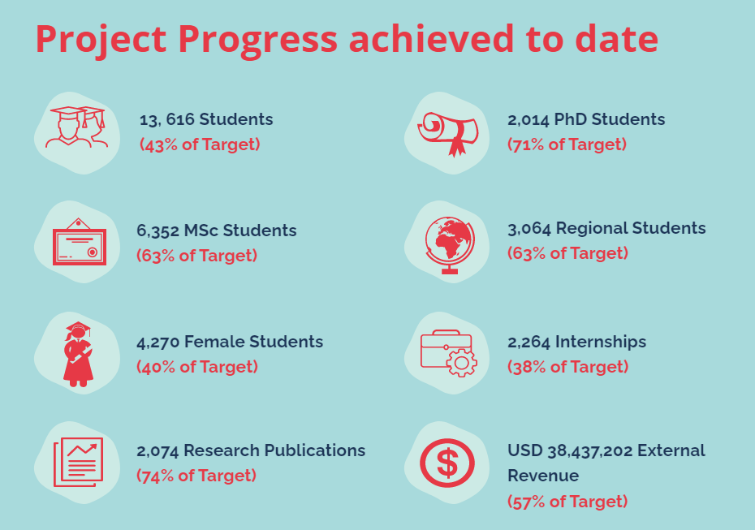

Communications Workshop: Capacity Development
Following lessons learnt from the implementation of communication activities in ACE I, the communications team recognized the need to enhance the knowledge and skills of the ACE Impact communication officers. In line with this, the Regional Facilitation Unit organized a three-day training workshop from April 24 - 26 2019 at the AAU Secretariat in Accra. Prior to this, a survey was conducted to identify the needs of the communication officers. Again, the websites of all 53 centres were thoroughly reviewed in preparation for the training. The workshop had over 52 participants from over 30 institutions including ACE II centres. Sessions were held by 2 communication professionals from the University of Ghana and the AAU Communications team. Topics covered included Roles of a Communications Expert, Developing Diverse Communication Strategies, Action Plan, and its Implementation; World Bank Communication Strategies for the ACE Project; Website Content Management; Use of various Social Media Tools and Improving Internal and External Communications as well as Media Relations. Hands-on training was provided through individual and team tasks on the various topics.

Further to this, a follow-up two-day communications capacity development workshop was held from 6th – 7th of April 2021 for all ACE Impact centres. The workshop had over 65 participants in attendance with representation from almost all ACEs under the project. Sessions were led by the World Bank Senior External Affairs Officer Sylvie Nenonene on the importance of ACE Impact project and communications for Africa’s Integration agenda. Further sessions were given by WB ACE Impact team and AAU communications team covering fact sheet development, website support and development, success story development, photography dos and don’ts and ACEs challenges. The workshop was a great success. Sessions were held both in French and English, with real-time translation services being offered to ensure participation and inclusivity for all. Templates to support the development of communications materials were shared with all ACEs also in both English and French. Continuous engagement, group tasks, Q&As after each session allowed for specific challenges and concerns to be raised by the ACEs and addressed immediately.
Progress of the ACEs is regularly monitored by the ACE Impact Team and a follow-up communications workshop will be held November 2021. The workshop will focus on progress made and core challenges the ACEs faced, finding solutions to the biggest obstacles over the past 6 months.

Media Engagement

The team has worked closely with various online portals including the University World News (UWN) in projecting the impact and successes chalked in project implementation. Stories featured by the UWN highlight ACE Impact contributions in COVID-19 management, capacity building trainings and overall project progress. The UWN confirmed that articles on the ACE Impact project are one of the most read and received positive feedback from readers.

Article on trainings: https://www.universityworldnews.com/post.php?story=20200909161135324
Article on overall project progress:https://www.universityworldnews.com/post.php?story=2021082510291545
Features: https://ace.aau.org/media/featured-articles/

Partnership with AAU TV:
The ACE Impact team has collaborated with the Association of African Universities (AAU) TV channel to deliver some exciting video content for the ACE Impact project. AAU TV is producing a series of educational documentaries on the different centres of excellence, providing the public and those in the education sector with an insight into the centres achievements, a look at their state-of-the-art facilities, opportunities to meet their students, explore their innovative research and much more. AAU TV has committed a dedicated team of four (4) to this project - a visual editor, a cameraman, a sound engineer, and a content producer, with the ability to avail further staff during field deployment.

A summary work-plan has been developed with plans to cover a different centre of excellence each month. A total of eight (8) centres will be documented up until June 2022, with the rest occurring in the next fiscal year. The first documentary covering the West African Centre for Cell Biology of Infectious Pathogens (WACCBIP) was completed early September 2021 (awaiting final approval) with the second documentary also under review. In addition to full feature documentaries, AAU TV will also be developing shorter video content and clips to be used for various communications channels and campaigns, including social media, YouTube channels, newsletters and more. Further to this, the documentary team will be capturing still photographs during their visits to expand the quality and quantity of the ACE Impact Photobank repository.

ACE Impact Quarterly Newsletter:
The ACE Impact Quarterly Newsletter was redesigned and relaunched at the beginning of 2021. Prior to the relaunch, seven (7) newsletters were shared in 2020. The newsletters emphasized mostly on the contributions made by the centres in managing the COVID pandemic in their respective countries and the continent at large. The newsletters reached over 500 subscribers and had over 50% engagement rate with 2, 156 opens.

ACE for Impact News

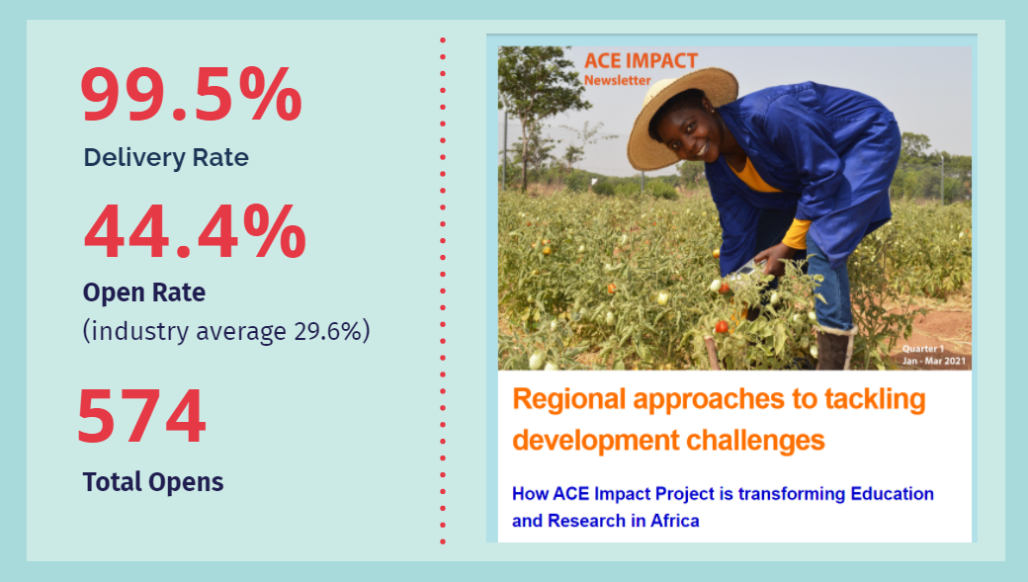
The first issue of the 2021 edition was released in April covering the period of January to March 2021, with the second issue released August 2021, covering the period of April to June 2021. The new design and layout developed specifically focuses on highlighting and showcasing the innovative and ground-breaking achievements from the centres, informing the public of new opportunities and scholarships available, showcasing a different centre of excellence per issue, sharing students and faculty stories and much more. The new ACE Impact newsletter has received much positive feedback, with zero unsubscribers and above industry average figures being reached.
ACE Impact Quarterly Newsletter January – March 2021 (Issue 1)
ACE Impact Quarterly Newsletter April – June 2021 (Issue 2)

Photo Bank:
The AAU is currently developing an image repository for all High-Definition images from the ACE Impact project. This image repository will help support the development of communications materials, as well as capture a visual story and representation for the project. The images will also be publicly available for external media to utilise. The platform being used is Flickr.
AAU Flickr Account: https://www.flickr.com/photos/aau-africa/albums/
Photo Bank ACE IMPACT: https://www.flickr.com/photos/aau-africa/albums/72157718340914272

Social Media Outreach:
Along with other communications channels, ACE Impact social media channels have seen a significant rise in online interaction and followers. A new social media action plan was developed by AAU to ensure strategic, targeted, and SMART social media outreach. These efforts, combined with the project’s increasing online footprint, have resulted in a steady increase in social media following over the reporting period. During the 5th ACE Impact Virtual Regional Workshop held in May 2021 the ACE Impact team was supported by 35 Social Media Reporters from the centres who volunteered their time and expertise to assist with coverage of the event. As a result of this huge team effort, comments and shares double and tripled respectively, with followers reaching an all-time high- 1,408 Followers on Twitter and 1,454 reach on Facebook.

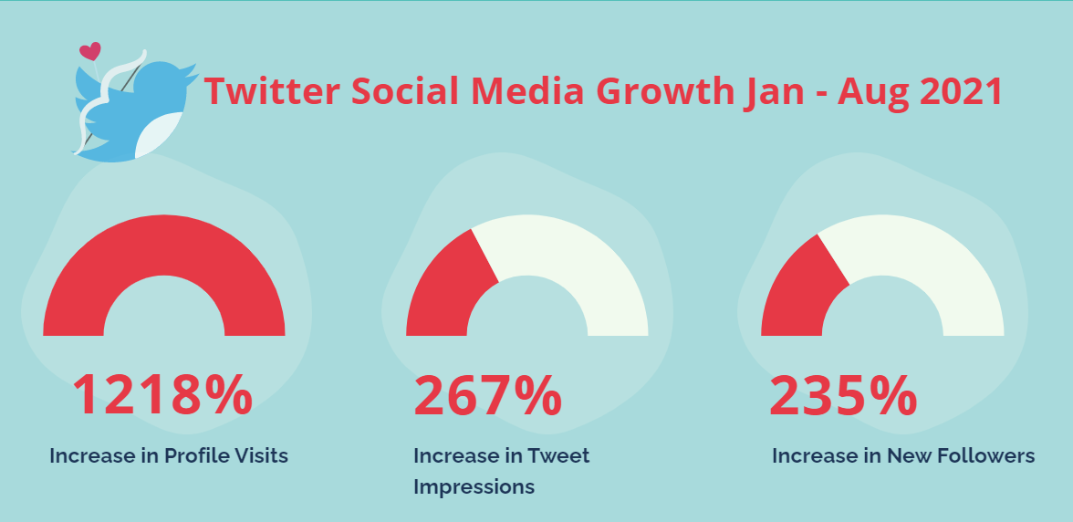

ACE Impact Twitter: https://twitter.com/the_ACEProject
ACE Impact Facebook: https://www.facebook.com/AfricaHigherEducationCentersofExcellence/
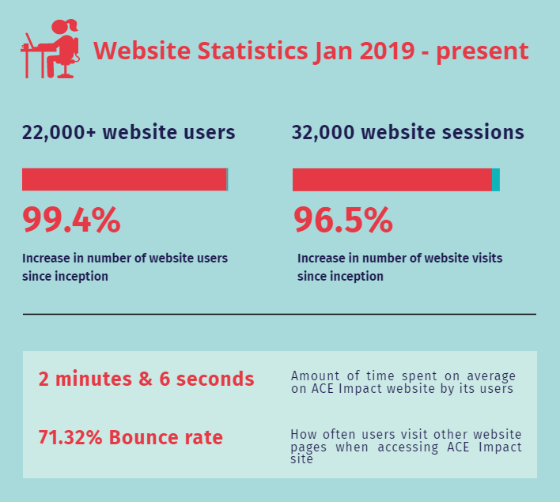
ACE Impact Website: The ACE Impact website is the primary online source of information for the ACE project. The website is updated regularly with the latest news and information emerging from the centres, calls for applications/proposals, guidance on application processes, webinars, events, and much more. All newsletters and articles are available on the website, as well as live links to ACEs respective website, social media handles, COVID-19 information, reports, published research, and much more. The website undergoes regular maintenance and assessment to ensure technical issues are immediately dealt with.
ACE Impact Stories:
With the recent push in focus on communications, the ACE Impact team has increased efforts to really capture the story and impact of the project. As a result of this, the team collected stories from students, both current and alumni, as well as centres faculty and staff. These stories are crucial in helping our various audiences visualise the day-to-day, on the ground impact of the project, allowing them to see the benefit of the project to students, faculty, the research space and generally its contribution towards solving Africa’s development challenges.
Website link: https://ace.aau.org/
Stories link: https://ace.aau.org/stories/
News link: https://ace.aau.org/news-announcements/

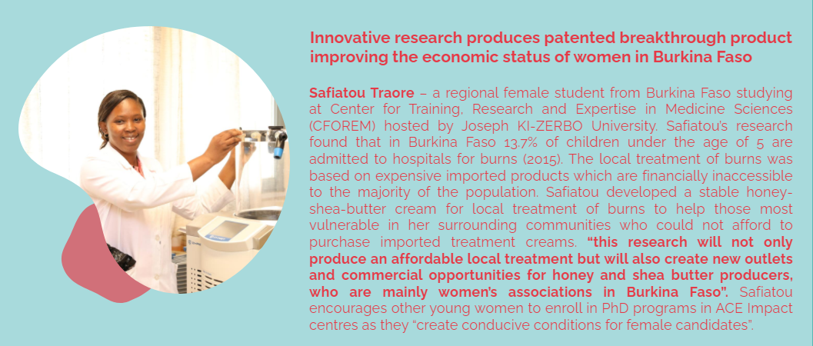

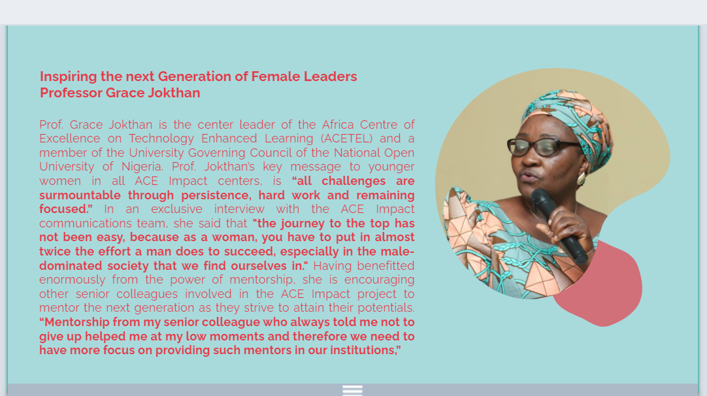

Africa Center of Excellence for Genomics of Infectious Diseases (ACEGID), Redeemer's University, Nigeria; (2) Africa Center of Excellence for Neglected Tropical Diseases and Forensic Biotechnology (ACENTDFB), Ahmadu Bello University, Nigeria; (3) Africa Center of Excellence on New Pedagogy in Engineering Education (ACENPEE), Ahmadu Bello University, Nigeria; (4) Africa Center of Excellence for Reproductive Health Innovation (CERHI), University of Benin, Nigeria; (5) Africa Center of Excellence in Dry Land Agriculture (CDA), Bayero University, Nigeria; (5) Africa Center of Excellence for Population Health and Policy (ACEPHAP), Bayero University, Nigeria; (6) Center For Food Technology and Research (CEFTER), Benue State University, Nigeria; (7) Africa Center Of Excellence for Mycotoxin and Food Safety (ACEMFS), Federal University of Technology Minna, Nigeria; (8) Africa Center Of Excellence for Drug Research, Herbal Medicine Development and Regulatory Science (ACEDHARS), University of Lagos, Nigeria; (9) Africa Center Of Excellence for Innovative and Transformations Stem Education (ACEITSE), Lagos State University, Nigeria; (10) Africa Center Of Excellence for Sustainable Power and Energy Development (ACE_SPED), University of Nigeria, Nsukka, Nigeria; (11) Africa Center Of Excellence in Future Energies and Electrochemical Systems (ACE-FUELS), Federal University of Technology Owerri, Nigeria; (12) OAU ICT-Driven Knowledge Park (OAU-Oak Park), Obafemi Awolowo University, Nigeria; (13) Center of Excellence for Oilfield Chemicals Research (CEFOR), University of Port Harcourt, Nigeria; (14) Africa Center of Excellence for Public Health and Toxicological Research, (ACE-PUTOR) University of Port Harcourt, Nigeria; (15) Africa Center of Excellence on Technology Enhanced Learning (ACETEL), National University of Nigeria; (16) Covenant Applied Informatics and Communication (CAPiC), Covenant University, Nigeria

